Welcome to the 2023-24 school year!

Greetings Battle Creek Elementary School Family!

Welcome to the 2023-24 school year! All of us at Battle Creek Elementary look forward to seeing students in grades 1-12 on Tuesday, September 5, and Pre-K and Kindergarten students on Thursday, September 7.

We are very excited for this next school year as we continue to grow community partnerships and strengthen our academic progress. In addition, we have built a strong partnership with Project Scientist which will provide E-STEAM learning opportunities for both staff and students.
At Battle Creek Elementary, you may also notice some changes around the outside of the building. We have a new pollination station and are continuing to work on building outdoor classroom spaces. All of these exciting things are helping to grow our E-STEAM program for all of our students.

Over the Summer, I did hire a new Assistant Principal for Battle Creek Elementary. Mr. Parks moved on to a new Assistant Principal role out of the district. Ms. Sara Johnson, will now serve in this role as our new Assistant Principal. She has worked for over 25 years in Saint Paul Public Schools as a Classroom Teacher, PAR Coach for new teachers, and an Academic Support Teacher. Ms. Johnson was a staff member at BCE this last school year so she has already built positive relationships with students, families and staff.

At Saint Paul Public Schools, our mission is to inspire students to think critically, pursue their dreams and change the world. This means providing challenging and engaging instruction in welcoming classroom environments that represent and respect the diverse backgrounds of our students. This way, every student can feel seen, empowered and ready to find joy in learning.

The first day of school is exciting for students, families and staff alike. It can also be overwhelming. Here are a few things to know so you can help your students be ready for the first day.

Open House
Please join us at our open house to welcome students and families to a new year on Thursday, August 31st from 3:30pm-5:30pm.

Classroom teachers assignments will be posted at Open House. Classroom Supply Lists are enclosed with this letter.
Teachers enjoy spending this time getting to know you and your family. They are happy to answer any questions you may have about classroom curriculum and instruction, the classroom schedule and grade level specifics.

School Hours
Arrival: 7:15am (doors open for breakfast)
Dismissal: 2:00pm
School doors open at 7:15am for students to enter the building for breakfast. School hours are from 7:30AM to 2:00PM. Teachers do begin classroom community building activities right after breakfast so please ensure your child is at school each day by 7:30am so they can be part of this important classroom community experience.

Transportation
Students will receive a postcard in the mail with transportation information at the end of August. The postcard lists details about where and when to get on and off the bus. Please arrive at the bus stop five minutes before the bus is scheduled to pick up your child. Track the status of your child’s bus on our school’s website or the Bus Status app.

If you believe your student is taking the bus but did not receive a postcard, please call Transportation at 651-696-9600 as soon as possible.

If you have moved over the Spring or Summer, please call our main school office beginning on August 29th. Our main school office line is: 651-744-4130
A change in address could result in a change of schools based on your new location. Our friendly office staff can assist you with this and questions you may have.

School Drop-off and Pick-up - Battle Creek Rec Center Parking Lot
Students should not be dropped off at school before 7:15am as staff are not available for supervision prior to 7:15am or after 2:00pm.
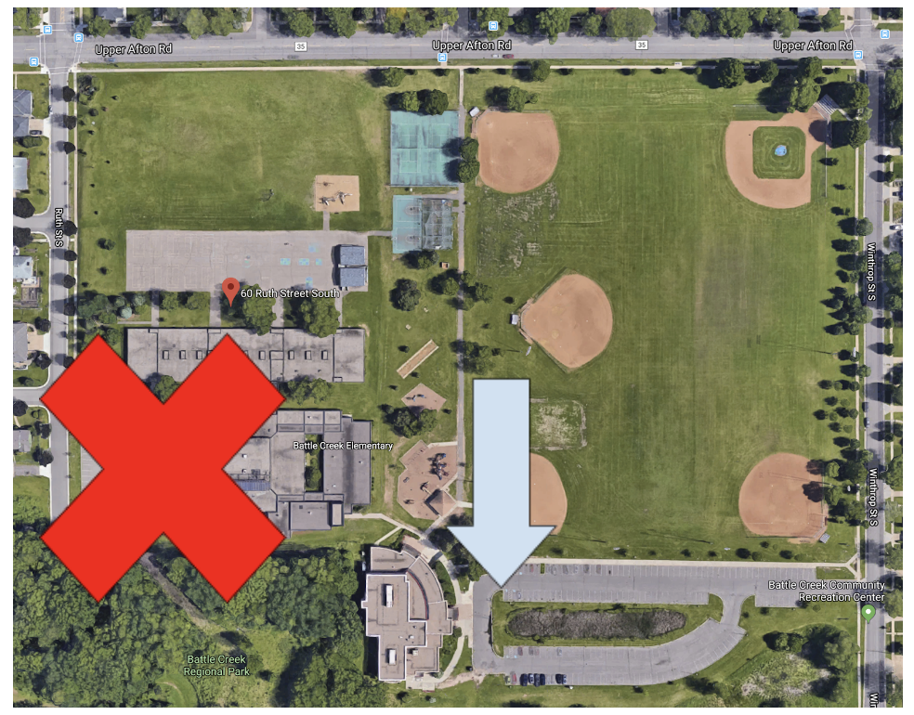
- Student drop off: Please park in the Battle Creek Rec Center parking lot at the back of the school. The back door of the school near the Battle Creek Rec Center will remain open until 7:30 am for students to be dropped off. The front of our school is only for bussing during drop off and pick-up times.
- Student pickup: Please park in the Battle Creek Rec Center parking lot and come into the school close to the Rec Center and then proceed up to the lunchroom to pick-up your child. Doors for picking students up are open by 1:55 with the pick-up door closing by 2:10. Staff are not available after school to stay with students so we encourage families to set-up daycare needs with the Battle Creek Rec Center or SPPS Discovery Club.
- Changes in end of the day routine/dismissal for your student: It is important for students to have a consistent dismissal routine each day. Parents must designate their student as a walker, parent pickup or a busser. Any changes to a students’ dismissal routine for the day must be requested by calling the office by 1:00pm to ensure that the information reaches the student in a timely manner.

Meal Information
All students are eligible to receive free breakfast and lunch under the Minnesota Free School Meal program. As students arrive at school, they can grab their breakfast and eat in class. Hot and cold breakfast options are available.

Single Item Purchases and Second Meals
Second meals, incomplete meals and single items, such as milk only, must be purchased. The 2023-24 meal and milk prices are:
- Student Second Breakfast: $2.85
- Student Second Lunch: $5
- Milk Only: $0.50
- For a complete list of prices, visit spps.org/ns.

Application for Educational Benefits
While all in-person students will receive free breakfast and lunch under Minnesota’s Free School Meals program, it remains critical that all families complete an Application for Educational Benefits each school year. These applications determine how much funding your child’s school receives for educational programs and supports. Additionally, eligible families can qualify for other benefits. The application can be completed online at schoolcafe.com/spps. Paper applications are available at school.

Immunizations
Please check in with your health care provider to make sure your child’s immunizations are up to date before school starts in the fall. Visit spps.org/immunizations or call our school nurse for more information.

Child Care Before and After School
Discovery Club is a fun and nurturing child care program for students in grades PreK-5 that supports learning and development before school*, after school, on non-school days and during the summer. Space is limited. For a list of fees, locations, and to register or join the waitlist, visit spps.org/discoveryclub or call 651-632-3793. *Before school care is unavailable for schools with a 7:30 a.m. start time.

Student Rights & Responsibilities
SPPS strives to create welcoming schools where each and every student is seen, known and valued. There are rights students are guaranteed when they are at school as well as responsibilities that accompany those rights. Families are strongly encouraged to review the Rights & Responsibilities Handbook.

Attendance is an important part of student success. We realize there are many reasons that a student may be absent from school. If your child will be absent from school, please notify the school at your earliest convenience. Communication between home and school is a vital component to a positive school experience.

School Safety
Safety is a top priority at our schools. Battle Creek Elementary does have an Emergency Operations Plan that is created specifically for our school and regularly reviewed. Families receive communication home when an incident directly impacts their students, such as a lockdown. Exterior doors are always locked and all visitors must sign in.

Families, students and staff can use the MySPPS app to “Send a Tip” and confidentially report unsafe behaviors to SPPS Security and Emergency Management (SEM). Every tip is taken seriously and acted on right away. Learn more at spps.org/safety.

Contact Information
Please check our school website regularly, https://www.spps.org/BattleCreekEl
for information and updates. If you have questions the website doesn’t answer, please call the front office at 651-744-4130.

Attached to this letter you’ll find the following important documents:
- School Supply List 23-24
- 2023-24 BCE Family Calendar
- SPPS Family Calendar 23-24

I’m looking forward to welcoming you and your child to a new school year. I’m so proud to be part of this wonderful school community!

Sincerely,

Kristen Longway

Kristen Longway, Principal
Battle Creek Elementary

